


i-net Clear Reports
Bar Charts
This report shows the usage of bar charts and stacked bar charts in reports.

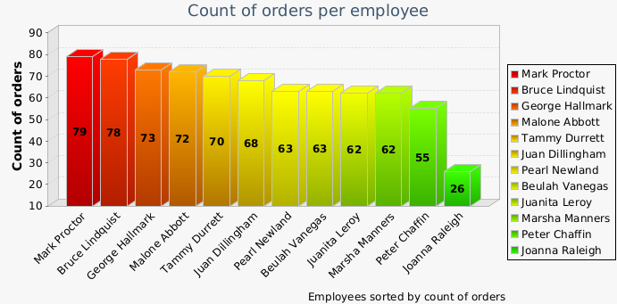
Employee name
Count of orders
Mark Proctor
79
Bruce Lindquist
78
George Hallmark
73
Malone Abbott
72
Tammy Durrett
70
Juan Dillingham
68
Beulah Vanegas
63
Pearl Newland
63
Marsha Manners
62
Juanita Leroy
62
Peter Chaffin
55
Joanna Raleigh
26

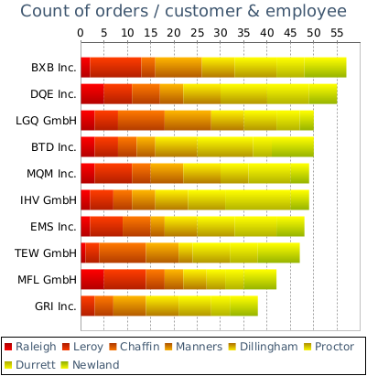
© Copyright 1996 - 2025, i-net software GmbH; All rights Reserved.
Page 1 of 1



