


i-net Clear Reports
Radar Chart Samples
This sample shows the usage of radar charts and stacked radar charts in reports.

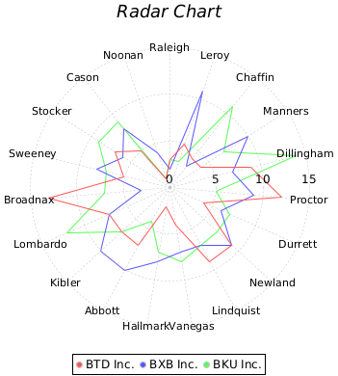

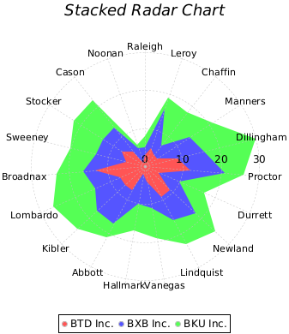
© Copyright 1996 - 2025, i-net software GmbH; All rights Reserved.
Page 1 of 1



